FINÁLNÍ PROJEKT   
 č.1



Autor: Jaroslav Pátek  
Datum: 1.7.2024

G

OBSAH

**ZADÁNÍ** **3**

**TESTOVACÍ SCÉNÁŘE** **4**

**EXEKUCE TESTŮ** **5**

**BUG REPORT** **5**

# ZADÁNÍ

ČCílem finálního projektu je otestovat funkčnost aplikace, která slouží k manipulaci s daty o studentech. Aplikace má rozhraní REST-API, které umožňuje vytvoření, smazání a získání dat..

## Přístupové údaje:

| Databáze | database: qa_demo Host: aws.connect.psdb.cloud Username: sgqcu2878p6q2zzw5tw4 Password: pscale_pw_SAp0dtsAQXPjI4DLtJT1zt8vvq1j3qu51ofWrqqIuzB |
| --- | --- |
| REST-API | http://108.143.193.45:8080/api/v1/students/ |

## Poznámky:

Nezapomeňte, že v IT se data musí někde uložit a poté získat. Proto ověřte, že data jsou správně uložena a získávána z databáze.

Nezapomeňte do testovacích scénářů uvést testovací data, očekávaný výsledek včetně těla odpovědi a stavových kódů.

Prepararion

:

# TESTOVACÍ SCÉNÁŘE

*Na základě uvedených testovacích scénářů jsem ověřil(a) funkčnost aplikace.*

**Test #1**

**Abstract: Get data about existing student**

**Test data preparation:**

Existing student id=242

SELECT * FROM student WHERE id=242;

‘242’ ‘34’ ‘[komar@seznam.cz](mailto:komar@seznam.cz)’ ‘Martin’ ‘KOMÁR’

**Steps:**

GET http://108.143.193.45:8080/api/v1/students/242

**Expected result:**

1. GET http://108.143.193.45:8080/api/v1/students/242
2. Press send button
3. status code: 200 OK
4. response:

{

“id”: 242

“first_name”: Martin

“last_name”: KOMÁR

“email”: [komar@seznam.cz](mailto:komar@seznam.cz)

“age”: 34

}

**Test #2**

**Abstract: Get data about nonexistent student**

**Test data preparation:**

Nonexistent student id=-1

SELECT * FROM student WHERE id=-1;

‘null’ ‘null’ ‘null’ ‘null’ ‘null’

**Steps:**

GET http://108.143.193.45:8080/api/v1/students/-1

**Expected result:**

1. GET http://108.143.193.45:8080/api/v1/students/-1
2. Press send button
3. status code: 404 Not found

**Test #3  
Abstract: Get data using a non integer value**

**Test data preparation:**

Non existing student id=null

SELECT * FROM student WHERE id=null;

‘null’ ‘null’ ‘null’ ‘null’ ‘null’

**Steps:**

GET <http://108.143.193.45:8080/api/v1/students/null>

**Expected result:**

1. GET <http://108.143.193.45:8080/api/v1/students/null>
2. Press send button
3. status code: 400 Bad request

**Test #4**

**Abstract: Delete all student data of an existing student**

**Test data preparation:**  
Existing student id=342

SELECT * FROM student WHERE id=342;

342 25 petrA@sova.cz Petra SOVA

**Steps:**

DELETE <http://108.143.193.45:8080/api/v1/students/342>

**Expected result:**

1. DELETE <http://108.143.193.45:8080/api/v1/students/342>
2. Press send button
3. All data about particular student are removed

**Test #5**

**Abstract: Delete all student data of a non existing student**

**Test data preparation:**

Non existing student id=3

SELECT * FROM student WHERE id=3;

null null null null null

**Steps:**

DELETE <http://108.143.193.45:8080/api/v1/students/3>

**Expected result:**

1. DELETE <http://108.143.193.45:8080/api/v1/students/3>
2. Press send button
3. status: 404 not found

**Test #6**

**Abstract: Delete data of student whose id is not an integer value**

**Test data preparation:**

Non existing student id=null

SELECT * FROM student WHERE id=null;

‘null’ ‘null’ ‘null’ ‘null’ ‘null’

**Steps:**

DELETE http://108.143.193.45:8080/api/v1/students/null

**Expected result:**

1. DELETE http://108.143.193.45:8080/api/v1/students/null
2. Press send button
3. status code: 400 Bad request

**Test #7**

**Abstract: Create new student using post method**

**Test data preparation:**

{

"firstName":"Willy",

"lastName":"Zaney",

"email":"willz95@gmail.com",

"age":30

}

**Steps:**

POST <http://108.143.193.45:8080/api/v1/students/>

Body -> raw -> JSON:

{

"firstName":"Willy",

"lastName":"Zaney",

"email":"willz95@gmail.com",

"age":30

}

**Expected result:**

1. POST <http://108.143.193.45:8080/api/v1/students/> | Body -> raw -> JSON:

{

"firstName":"Willy",

"lastName":"Zaney",

"email":"willz95@gmail.com",

"age":30

}

1. Press send button
2. status code: 201 created | database record matches input | REST API response:

{

"firstName":"Willy",

"lastName":"Zaney",

"email":"willz95@gmail.com",

"age":30

}

**Test #8**

**Abstract: Creating new student with the POST method without mandatory data**

**Test data preparation:**

{

"firstName":"Don",

"lastName":"Key",

"age":30

}

**Steps:**

POST <http://108.143.193.45:8080/api/v1/students/>

Body -> raw -> JSON:

{

"firstName":"Don",

"lastName":"Key",

"age":30

}

**Expected result:**

1. POST http://108.143.193.45:8080/api/v1/students/ | Body -> raw -> JSON:

{

"firstName":"Don",

"lastName":"Key",

"age":30

}

1. Press send button
2. status code: 400 bad request, error message: “email, lastName are mandatory”

**Test #9**

**Abstract: Student records are saved as lowerCase() in the database**

**Test data preparation:**

{

"firstName":"ChRiS p.",

"lastName":"BaCoN",

"email": "eBlAn123@yourmail.com",

"age":20

}

**Steps:**

POST http://108.143.193.45:8080/api/v1/students/

Body -> raw -> JSON:

{

"firstName":"ChRiS p.",

"lastName":"BaCoN",

"email": "eBlAn123@yourmail.com",

"age":20

}

**Expected result:**

1. POST http://108.143.193.45:8080/api/v1/students/ | Body -> raw -> JSON:

{

"firstName":"ChRiS p.",

"lastName":"BaCoN",

"email": "eBlAn123@yourmail.com",

"age":20

}

1. Press send button
2. status code: 201 created | new student information matches user input and is saved as lowercase in the database | REST API response:

{

"id": 1331,

"firstName": "ChRiS p.",

"lastName": "BACON",

"email": "eBlAn123@yourmail.com",

"age": 20

}

**Test #10**

**Abstract: Age of new student is in range between 1-150**

**Test data preparation:**

{

"firstName":"Easton",

"lastName":"West",

"email": "eastonW@gmail.com",

"age": 151

}

**Steps:**

POST http://108.143.193.45:8080/api/v1/students/

Body -> raw -> JSON:

{

"firstName":"Easton",

"lastName":"West",

"email": "eastonW@gmail.com",

"age": 151

}

**Expected result:**

1. POST http://108.143.193.45:8080/api/v1/students/ | Body -> raw -> JSON:

{

"firstName":"Easton",

"lastName":"West",

"email": "eastonW@gmail.com",

"age": 151

}

1. Press send button
2. status code: 400 bad request | error message: “age must be a number in range of 1-150

**Test #11**

**Abstract: Email is in invalid format when creating new student using POST method**

**Test data preparation:**

{

"firstName":"Jack",

"lastName":"Pott",

"email": "123456789",

"age": 20

}

**Steps:**

POST <http://108.143.193.45:8080/api/v1/students/>

Body -> raw -> JSON:

{

"firstName":"Jack",

"lastName":"Pott",

"email": "123456789",

"age": 20

**Expected result:**

1. POST http://108.143.193.45:8080/api/v1/students/ | Body -> raw -> JSON:

{

"firstName":"Jack",

"lastName":"Pott",

"email": "123456789",

"age": 20

}

1. Press send button
2. status code: 400 bad request | error message: “email must include @ and a valid domain”

# EXEKUCE TESTŮ

*Testovací scénáře jsem provedl(a), přikládám výsledky testů.*

Test #1 Result: Pass (check image below)

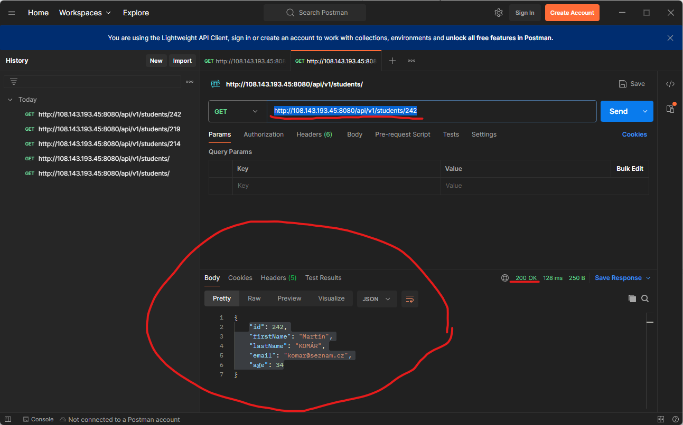

Test #3 Result: Pass (check image below)

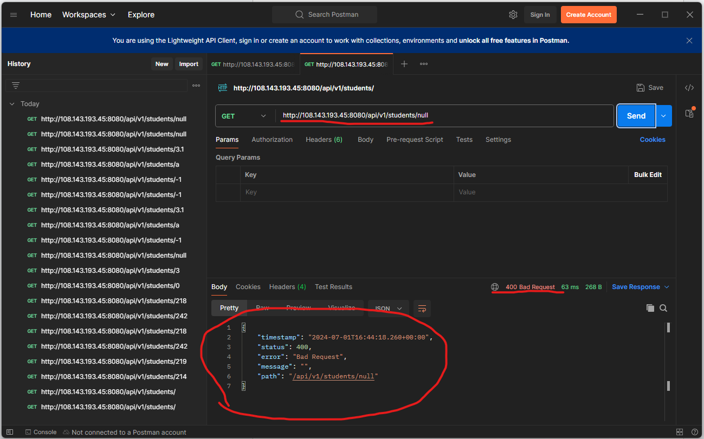

Test #4 Result: Pass (check image below)

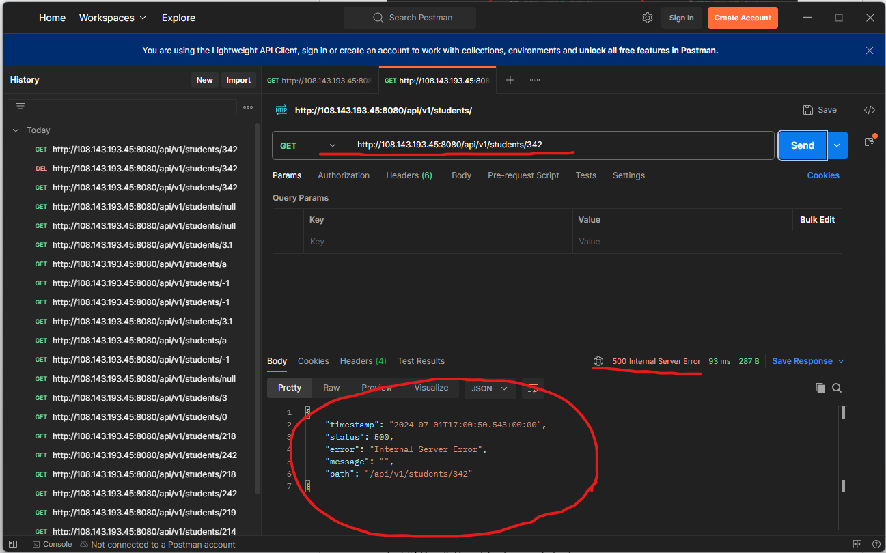

Test #6 Result: Pass (check image below)

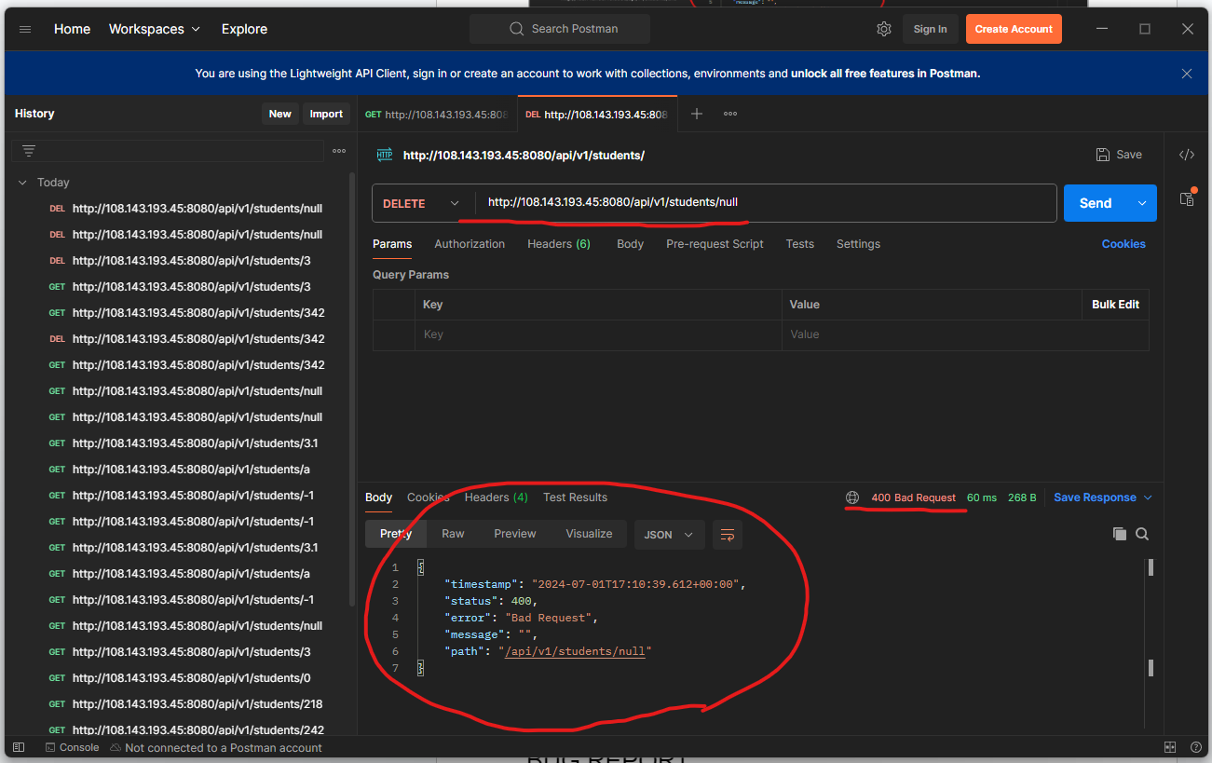

# BUG REPORT

*Na základě provedených scénářů jsem objevil(a) uvedené chyby aplikace.*

Test #2 Result: Fail (check image below)

Test #5 Result: Fail (check image below)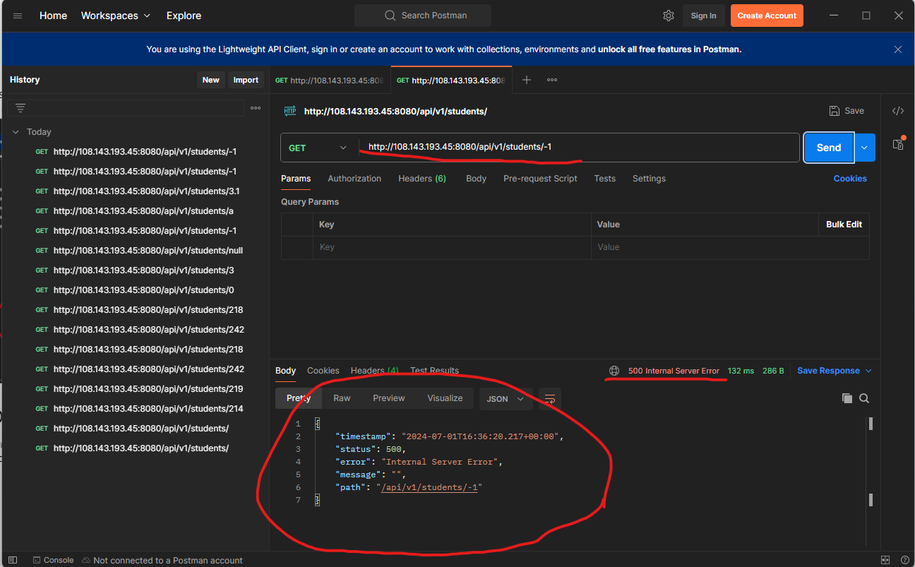

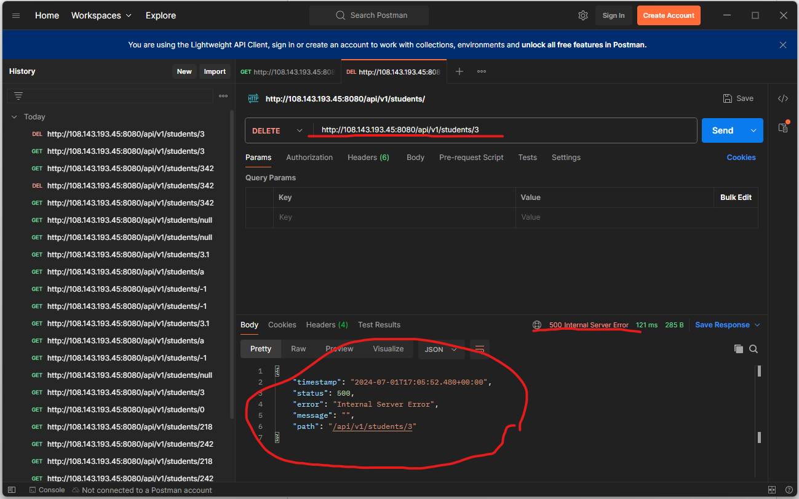

Test #7 Result: Fail (check images below)

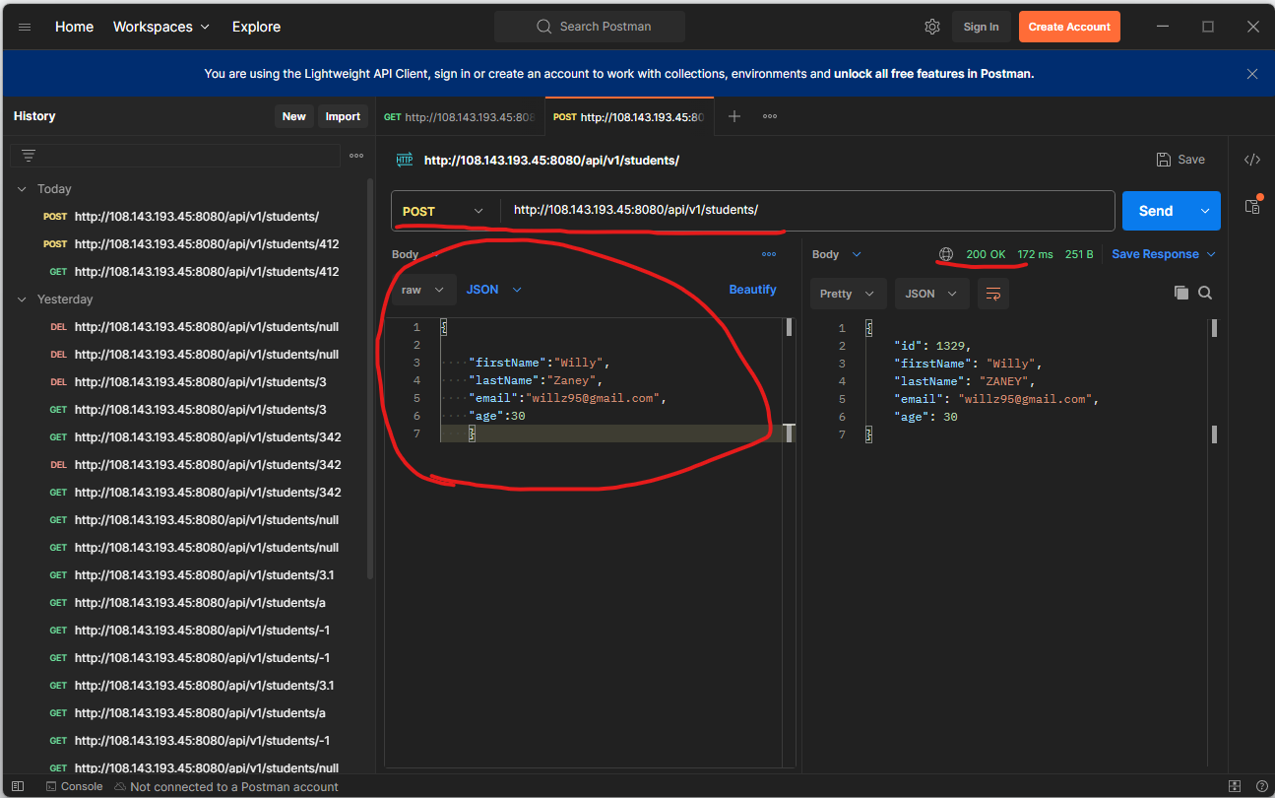

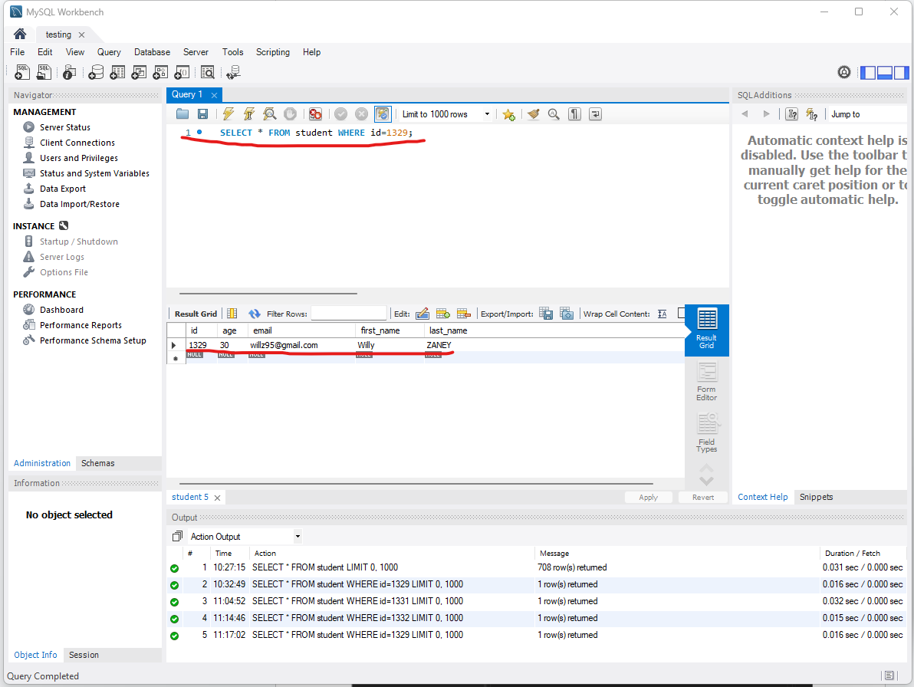

Test #8 Result: Fail (check image below)

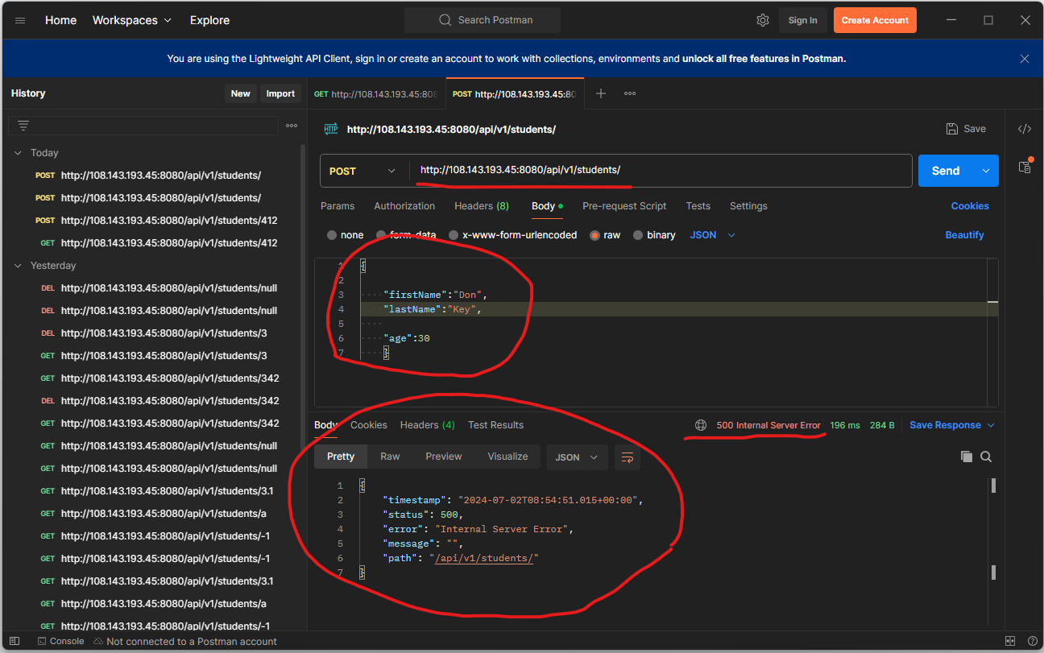

Test #9 Result: Fail (check images below)

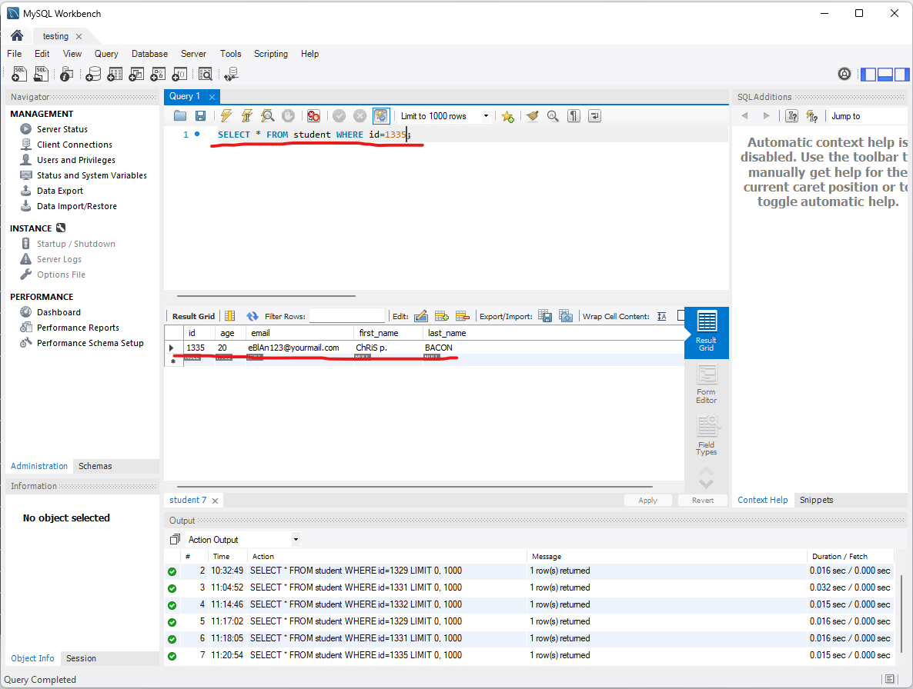

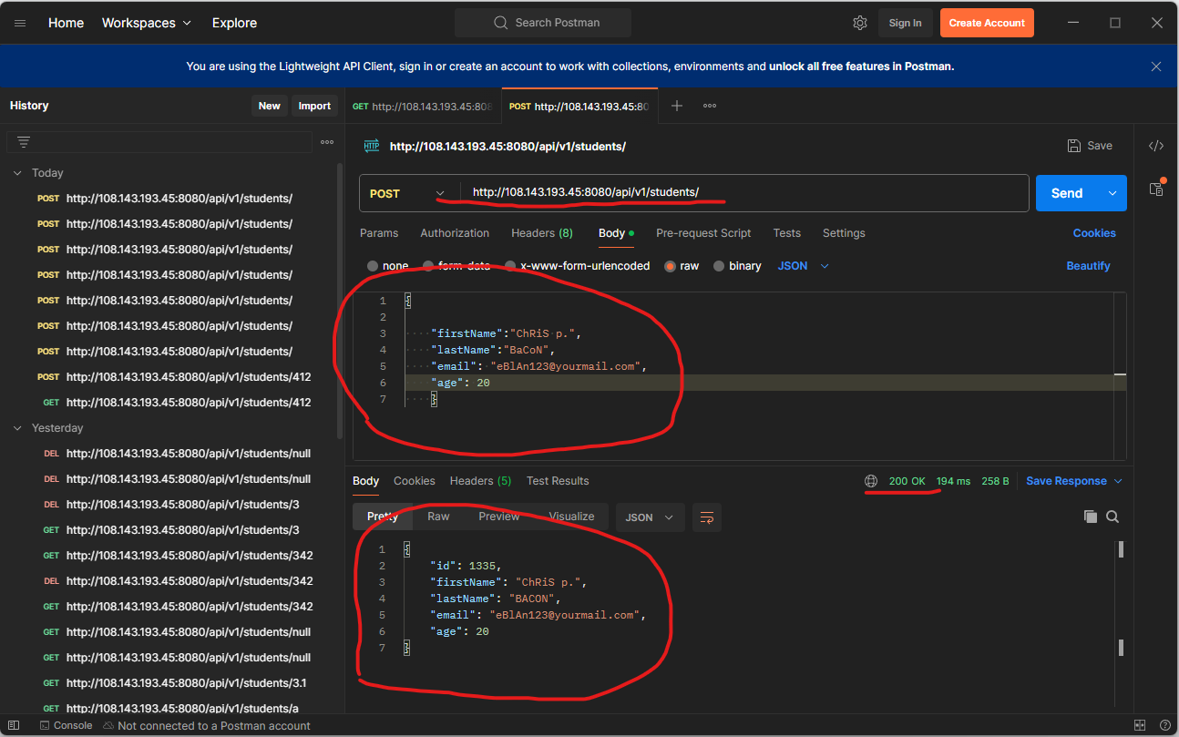

Test #10 Result: Fail (check images below)

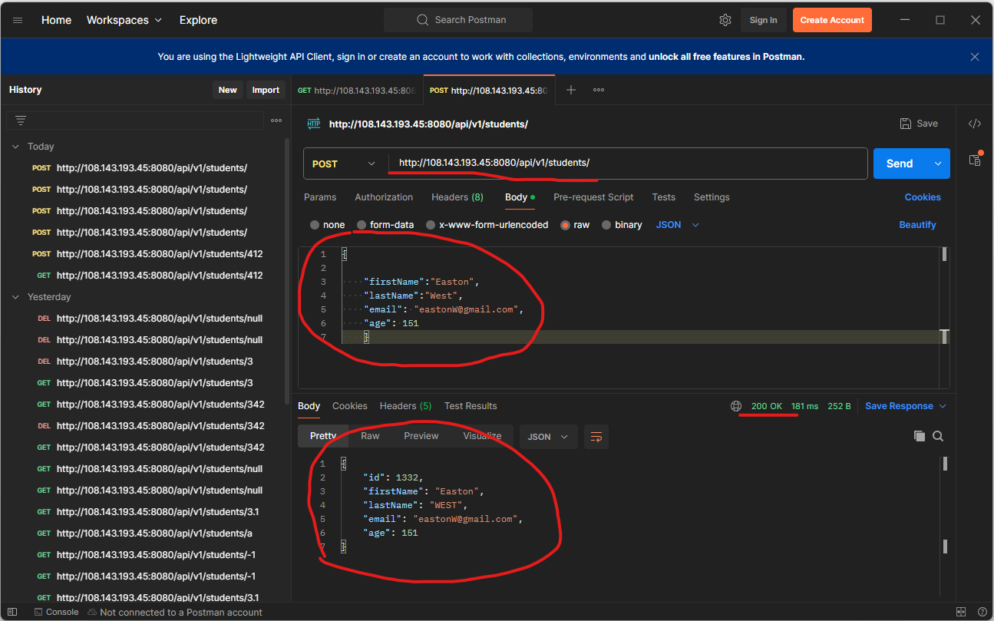

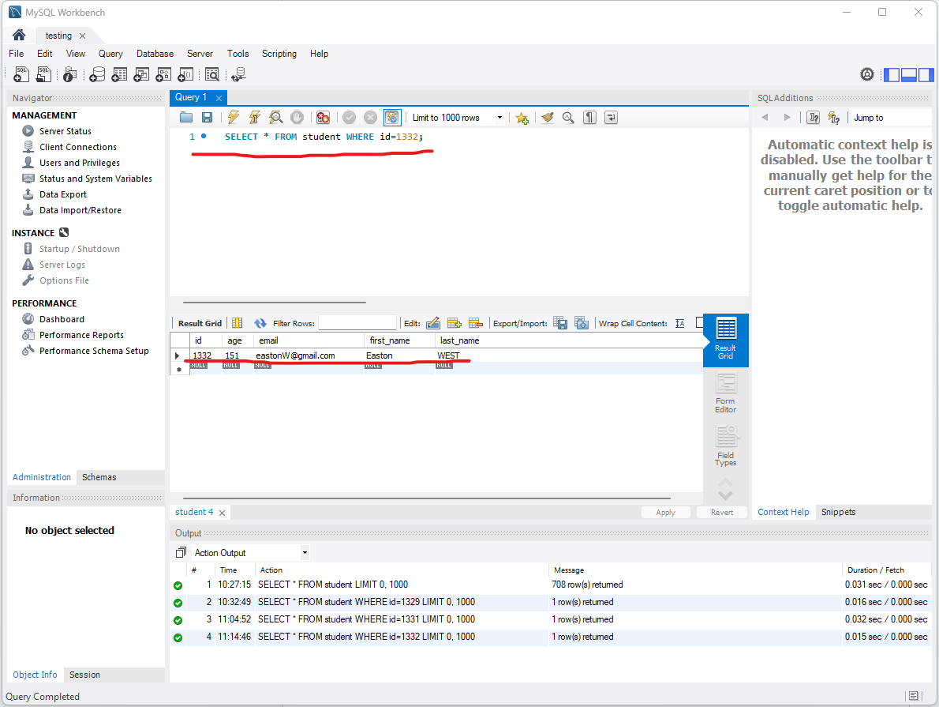

Test #11 Result: Fail (check images below)

